Area Dice Game
(2 or 3 players)

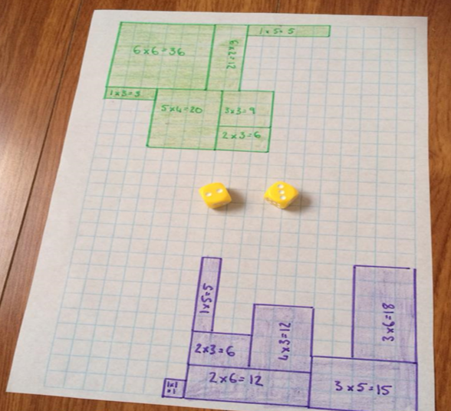

Materials:
- Graph paper
- A different coloured pencil for each player
- 2 six-sided dice
- A paper & pencil to keep score.

Directions:
- Players take turns rolling the dice. Draw a rectangle or square with that perimeter.
- Write the area inside the shape, then write that total on the score sheet.
- Keep playing until the graph paper is covered, or until each player has had two turns without having enough room left to draw the shape.
- The winner is the player with the greatest area covered.

